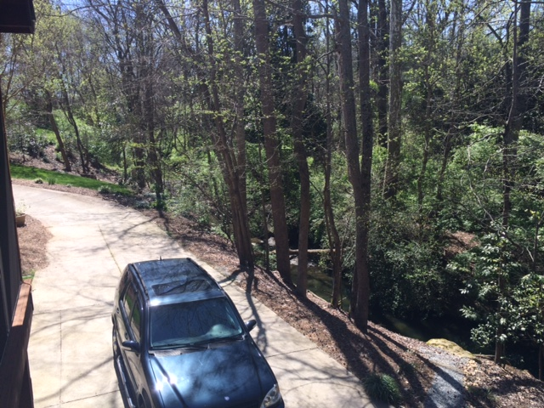
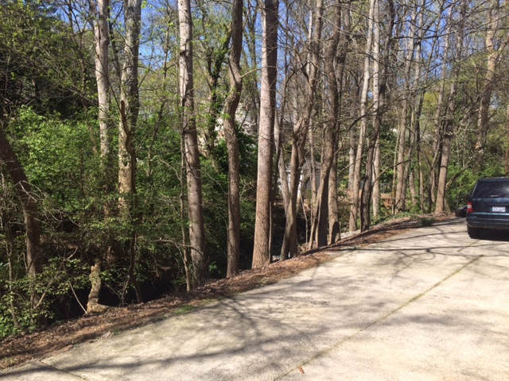
View of backyard along driveway and creek. Need to create a barrier that gives the illusion of safety for small children, bikes, toys, etc. Maximize visual impact to create a sense of being on vacation in your own backyard. We have abundant wildlife that visits the creek and we enjoy seeing them from the deck above. We have an area to feed the fish and have a feature called “Fish Rock” that overlooks the creek. The rock was in place when we bought the house and we’ve added the gravel path. There are hawks, owls, heron, ducks, backyard birds, raccoon, opossum, occasional deer. Well, you can keep out the deer.

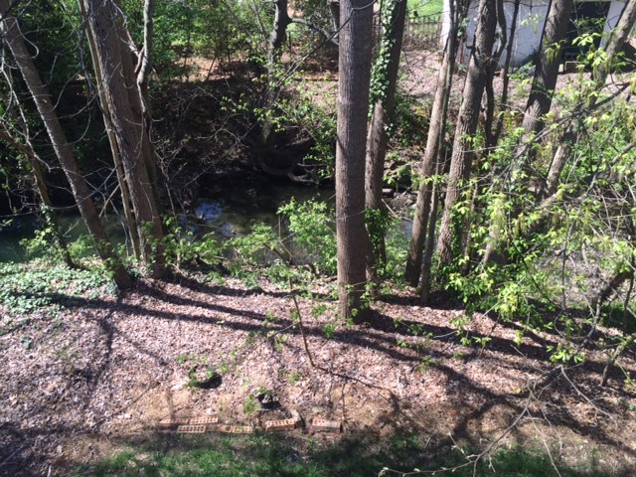
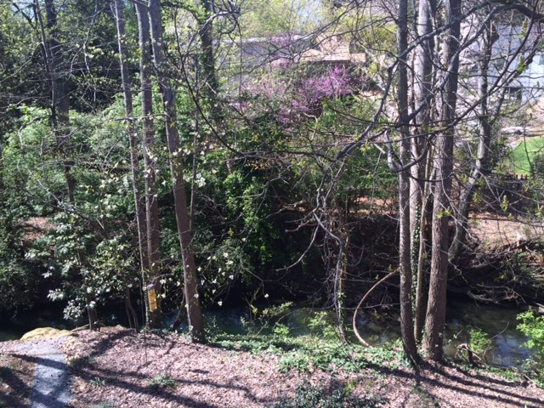

The areas above are directly on the creek. Most of it is currently naturalized. The building project at the corner of Morrison and Barclay Downs incorporated a cistern system that controls the storm water runoff and has eliminated any flooding issues with heavy rainfall. We could create a plan that incorporates 2 feet more of this space and that would increase the perception of a usable backyard.

- Marry the side yard and the backyard together to create a unified space that extends to the creek border. Existing landscaping along the side of the house and property line can be modified to fit such a plan.

- Include area under the deck to be perceived as usable backyard space.
- Currently planted with hostas for a cool summer look.
- Directly under the porch there is a stamped concrete pad.

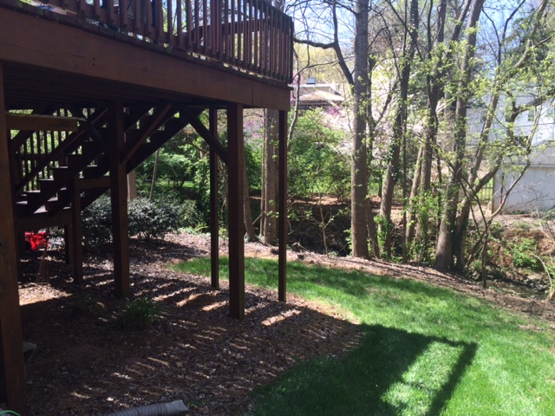
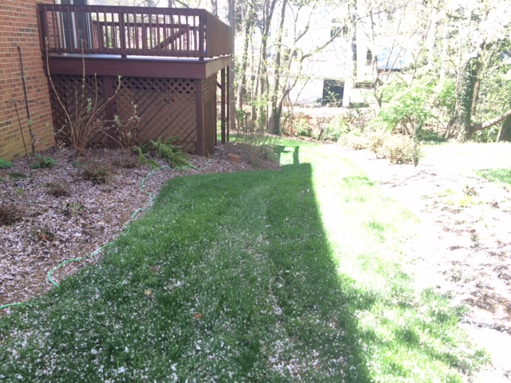

- We have a yard on the other side of the house which could be modified to function as valuable space.
- We have a small piece of yard on the other side of the driveway that borders the creek and slopes down to the creek. This area includes a sliver of land that is “behind” the neighbors property. We could include the yard space in the plan and then landscape out the part behind the neighbor’s house.
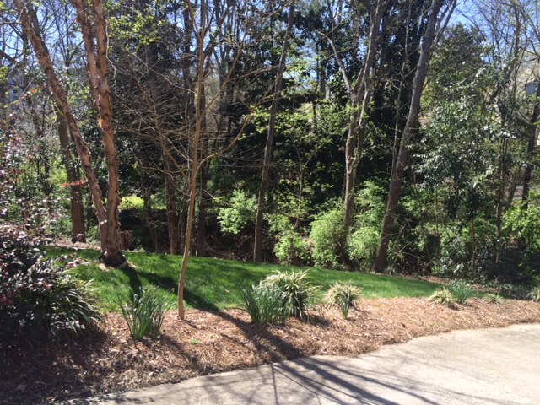
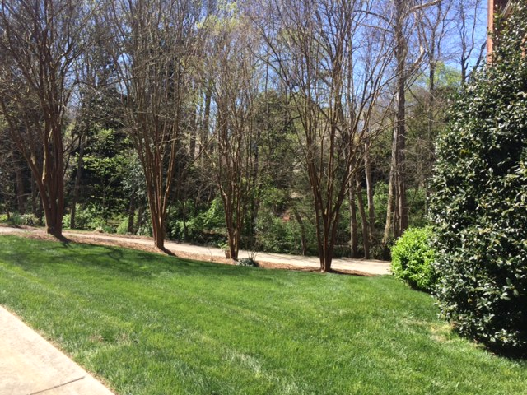
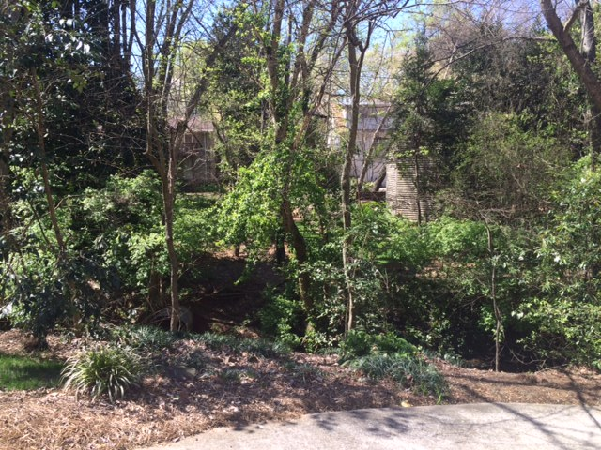
- This is the view when you proceed down the driveway. We need to enhance this view as you can see the erosion and culvert from the other side of the creek each time you pull down to the garage.

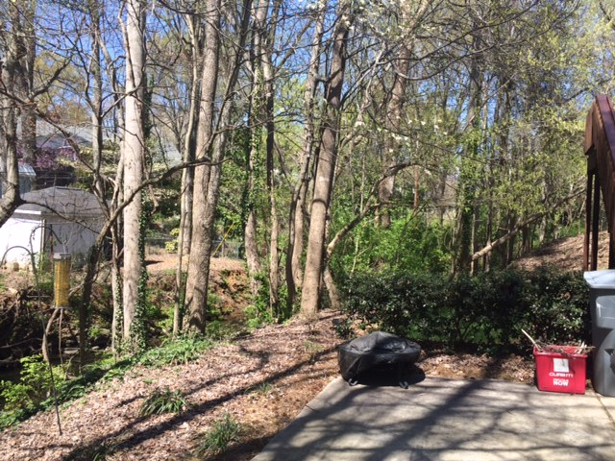
- Holly bushes at the end of the driveway could be removed. This would increase the flow from the driveway to the backyard and increase the visual perception of space.

Goal of this project is to “create” valuable backyard space

